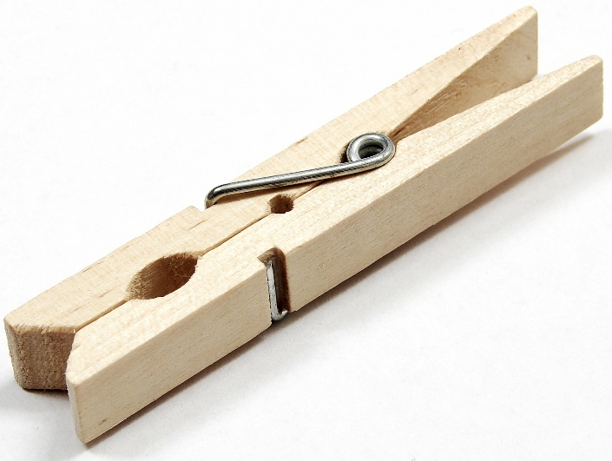
Classroom Discipline Plan
In my classroom, each student is responsible for their own behavior. The students are responsible for managing the emotions they may encounter throughout the day. Each student will be given clothespins in a baggy. Each student will get ten clothespins. Along with the clothespins in the baggy there will be cards. Each card will have the five classroom guidelines on it. On the card it will also have a name place, date, a student explanation, and a teacher explanation. It will look like this:
Name: Date:

Rule that was not followed:
Be safe by not hitting each other or running around the room.

Student explanation of what occurred and why: _____________________________________
________________________________________________________________________________________________________________________________________________________

Teacher explanation of what occurred: ____________________________________________
________________________________________________________________________________________________________________________________________________________

When a student does not follow the rule. The teacher present will take a clothespin and find the corresponding card and pin the clothespin to the card. The teacher will give the card to the student and explain why they are giving the card to the student. The student will then fill out the card and present the clothespin attached to the card to the teacher present. The teacher present will then write what they remembered occurred on the card. Then the student and teacher will talk about what happened when both have finished filling out the card.
The first time a student has a clothespin attached to a particular card, the student will stop and reflect about what occurred with the help of the teacher. If the student has another clothespin attached to the same guideline not followed from before then the student will have a conversation with the teacher before or after school to talk more about what is happening that is leading to the guideline being broken. If there is a third offense then the teacher will either email or call home to a guardian. A fourth offense will result in an office referral.
There is also an incentive with the clothespins. There will be a store in the classroom where the students are able to get little trinkets and coupons for the classroom. Each week the students will be able to take the clothespins they did not have taken away and use them to buy items from the store. The clothespins will then be restocked at the end of each week after the store is available.

