Philosophy of Classroom Management
Bridget Redder
University of Mary

Philosophy of Classroom Management
When teachers first think about classroom management they tend to think it is the management used in a classroom to maintain and control. According to Gary Borich, classroom management “focuses on planning and organizing the classroom, teaching rules and routines, and informing students of the consequences of breaking the rules” (Borich, 2017, p. 434). This definition helps set up what should be in a classroom management plan/philosophy. A classroom philosophy should include procedures, classroom rules, and a discipline plan. In this philosophy effective strategies and their importance in a classroom will be discussed.
One of the more important components of a classroom management plan are procedures. In a video titled “Using the First Days of School” Chelonnda Seroyer said procedures are “in place so the students know what I expect from them on a day to day basis.” Procedures happen from the moment when students enter the classroom and until they leave which is why they are so important. Some of the most important procedures are some of the simplest activities we do each day. One is bathroom breaks. Appendix A shows two simple procedure for bathroom breaks listed under procedure 6. If a bathroom break was not in place then many students would walk out of the classroom and the teacher would not know where they were. This is why a procedure to do this is so important; they keep us safe. Other important procedures include entering the room and dismissing class. These two seem simple, but when students are allowed to choose how they do them it can be chaos. Also the teacher can lose control of the classroom. When that happens it is difficult to regain the student’s focus. Other procedures that are important in a classroom are found in Appendix A like taking attendance and roll call, lining up, and getting into groups. These procedures are done very differently in each classroom. Which is why it is so essential for each teacher to establish how they expect the students to do each. Procedures are important in a classroom because they help keep the students safe and helps the teacher keep control.
A second component to a classroom management philosophy is classroom rules. “Effective teachers produce results from a classroom that is predictable, reliable, and consistent” (Wong & Wong, 2014, p. 11). In every classroom there is something which is predictable, reliable, and consistent they are the classroom rules. These are put in place to hold students accountable for their actions. One of the classroom rules in Appendix B is to be safe. This is important, because when a classroom is safe the students can feel safe themselves and be the best possible version of themselves by working hard. Also another rule is using kind words when working or talking to each other. This rule is important because in life being positive is important. Also maintaining a bubble of personal space is a classroom rule that helps students. This helps students because they can have a work space that is all their own. Also being positive helps everyone in the classroom have a better day. The first classroom rule listed in Appendix B is before you speak THINK. This rule is important, because many students may want to tell the class something that is not important. So to have this as a rule helps the teacher to regulate what students should say in a classroom. Classroom rules allow the teacher to have set expectations in a classroom.
Lastly, a discipline plan is an important component in a classroom management plan. A disciple plan is put in place to have a plan of how to react to a behavior in a classroom. “Discipline is concerned with how students behave” and “disciple has penalties and rewards” (Wong & Wong, 2014, p. 9). In the discipline plan in Appendix C it shows what the students should do and has penalties and rewards for the students. Discipline plans are important because they let the students know what will happen if they do not follow a rule in the classroom. It is also important for the teacher to be consistent with punishing students. In the discipline plan in Appendix C there is a card that students will be given. This card will hold the students accountable for their actions. This will help both the student and the teacher understand what is happening with the behavior. Also in the plan is a plan for rewarding the students. When students behave accordingly, it is important to let them know as the teacher that they are seen doing so. Overall, a discipline helps the teacher stay consistent with discipline while also giving accountability to the student.
All in all, a classroom plan/philosophy should be well thought out and include classroom procedures, rules, and a discipline plan. Procedures are important in a classroom so students can have ways of doing things and not feel like they do not know what they need to do. Classroom rules are important to make the classroom safe. A discipline plan helps a teacher discipline students when they do not follow the rules and also gives student incentives when they do. Procedures, rules and a discipline plan are all important when a teacher is in a classroom.
Appendix A
Classroom Procedures
- Procedure 1: Entering the Room
  - Give a fist bump and smile to greeter at the door
  - Continue to walk in quietly
  - Do the procedures that follow for that day
  - *If need to tell the teacher something, step to the side and wait until everyone is in the classroom before talking to the teacher. This will allow the teacher to continue greeting the other students.
- Procedure 2: Lining Up
  - Stand up quietly
  - Push in chair if at desk
  - Line up in line order without touching those around you
  - Keep eyes forward and mouth quiet
  - Watch where you are walking
  - *Voice Level Zero
- Procedure 3: Getting into groups
  - If assigned to partner
    - After you are told your partner:
    - Quietly get up
    - Move next to partner
    - Move to the location in the classroom designated for you and your partner
    - Work on assignment quietly
    - *Voice Level One
  - If you pick partner
    - Look your preferred partner in the eyes without standing up
    - If they are looking at you too then stand up
    - Go stand next to each other
    - If they are not looking at you find a person who is looking at you
    - Wait for teacher to dismiss you before moving to an area of the classroom away from another group
    - *Voice Level Zero
  - If partner is chosen by Speed Dial
    - Get out your phone
    - Teacher will pick a speed dial
    - Quietly get up
    - Move next to the partner on the speed dial
    - Wait for teacher to dismiss you before moving to an area of the classroom away from another group
    - *Voice Level One
- Procedure 4: Taking attendance and Lunch Count
  - *Happens when students enter the classroom each morning
  - Find popsicle stick with name on it
  - Put on corresponding plate either hot or cold
    - The plates signify if they want hot lunch or they brought cold lunch
  - *The lunch helper will count the popsicle sticks on each plate and fill out sheet
Lunch Count and Attendance
Hot Lunch

Cold Lunch

Absent Students: _________________________________________________
________________________________________________________________

- Procedure 5: Replacing Dull or Broken Pencils
  - Find the teacher
  - Put pencil in hand
  - Wait for a nod from teacher
  - Walk over to the pencil jars
  - Put old pencil in used pencil jar
  - Take new pencil from new pencil jar
- Procedure 6: Bathroom Breaks
  - Classroom Bathroom Breaks
    - Walk to bathroom in a line
    - Students walk to the bathroom
    - Once done in the bathroom
    - The students come back out and they line up how they come out.
      - *Do not need to be in line order
    - Students walk back to the classroom
    - Voice level zero
  - Individual Bathroom Breaks
    - Find the teacher
    - Put your fingers in the sign language “r”
    - Wait for a nod from teacher
    - Voice Level Zero
- Procedure 7: Collecting Papers
  - In pods
    - Pass all papers to the middle of the pod
    - Have the pod leader take the papers
    - Pod leader makes sure that everyone’s name are on the papers
    - Pod leader raises the papers in the air
    - Teacher goes around and takes the papers from the pod leaders
  - In rows
    - Pass the papers to the desk to the left
    - Once the papers are at the end the row leader should have all the papers
    - Row leader makes sure that everyone’s name are on the papers
    - Row leader raises the papers in the air
    - Teacher goes around and takes the papers from the row leaders
- Procedure 8: Dismissing the Class
  - Wait for teacher to signal clean up time
  - Put homework in homework folder
  - Organize things around desk, throw away things if need be
  - Put all materials that are going home on top of desk.
  - Wait for teacher to dismiss you/group
  - Walk to locker with material going home and put in book bag
  - Bring book bag and coat into the classroom and stand by desk
  - Get dressed with coat and put book bag on
  - Wait for teacher to signal that you can line up
  - Line up at the door
  - Once everyone is lined up at the door sing the following as a class
  - Once done with the song, wait for the bell to ring.
- Procedure 9: Taking a Test
  - Have students grab dividing folders
  - Put around desk so others around cannot see
  - Wait for teacher to hand out test
  - Take the test while keeping eyes on own paper
  - If you need help raise hand and wait for teacher quietly
  - When done raise hand and teacher will pick up test
  - When everyone is done return dividing folder to original place
- Procedure 10: Snack Time
  - Clean off desk
  - Wash hands
  - Take out and eat snack
  - Pick up any crumbs in your area
  - Take out materials for next activity/subject
- Procedure 11: Classroom Phone Ringing
  - The person who is the secretary for the day answers the phone
  - If the secretary is not in the room the teacher is the next person to answer the phone
  - If the teacher is busy and the secretary is out the person nearest the phone answers it.
  - The person who answered the phone reads the script next to the phone
    - The script: Please say room #, student speaking
      - Follow with one of the following prompts
        - Just a minute, please. Let me tell the teacher.
        - The teacher will be here soon.
        - The teacher will call you back when she has time.
- Procedure 12: Lock Down
  - Turn off all lights
  - Lock the door(s)
  - Close all the shades in the room
  - Calmly walk to an area that is out of view from any windows or doors
  - Sit quietly
  - Wait for the all clear

Appendix B
Classroom Guidelines
*Before you speak THINK:
- Is it True?
- Is it Helpful?
- Is it Inspiring?
- Is it Necessary?
- Is it Kind?

*Be safe by not hitting each other or running around the room.

*Use kind words when working or talking to each other.

*Maintain a bubble of personal space.

*Be positive.

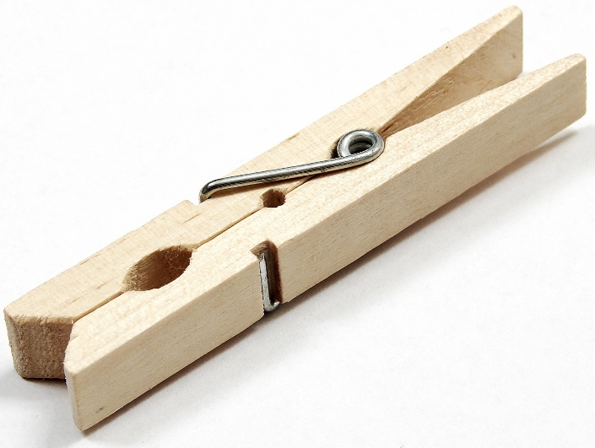
Appendix C

Classroom Discipline Plan

In my classroom, each student is responsible for their own behavior. The students are responsible for managing the emotions they may encounter throughout the day. Each student will be given clothespins in a baggy. Each student will get ten clothespins. Along with the clothespins in the baggy there will be cards. Each card will have the five classroom guidelines on it. On the card it will also have a name place, date, a student explanation, and a teacher explanation. It will look like this:
Name: Date:

Rule that was not followed:
Be safe by not hitting each other or running around the room.

Student explanation of what occurred and why: _____________________________________
________________________________________________________________________________________________________________________________________________________

Teacher explanation of what occurred: ____________________________________________
________________________________________________________________________________________________________________________________________________________

When a student does not follow the rule. The teacher present will take a clothespin and find the corresponding card and pin the clothespin to the card. The teacher will give the card to the student and explain why they are giving the card to the student. The student will then fill out the card and present the clothespin attached to the card to the teacher present. The teacher present will then write what they remembered occurred on the card. Then the student and teacher will talk about what happened when both have finished filling out the card.
The first time a student has a clothespin attached to a particular card, the student will stop and reflect about what occurred with the help of the teacher. If the student has another clothespin attached to the same guideline not followed from before then the student will have a conversation with the teacher before or after school to talk more about what is happening that is leading to the guideline being broken. If there is a third offense then the teacher will either email or call home to a guardian. A fourth offense will result in an office referral.
There is also an incentive with the clothespins. There will be a store in the classroom where the students are able to get little trinkets and coupons for the classroom. Each week the students will be able to take the clothespins they did not have taken away and use them to buy items from the store. The clothespins will then be restocked at the end of each week after the store is available.

References
Borich, G. D. (2017). Effective Teaching Methods: Research-based Practice. Boston, MA: Pearson.
Seroyer, Chelonnda. (speaker) & Wong, Rosemary (voice over). Using the First Days of School [Video Podcast].
Wong, H. K. & Wong, R. T. (2014). The Classroom Management Book. Mountain View, CA: Harry K. Wong Publications.

